String Class

1. **Remember**: Without knowledge of String, StringBuffered
   1. Don’t go for SCJP Exam
   2. Don’t go for Interview room
   3. Can’t write even a simple program confidently.
2. **String**: once we create a string object, we can’t perform any changes in the existing object. If we are trying to perform any change with those changes, a new object will be created. This non-changeable behavior is nothing but **immutability** of String.

**StringBuffered**: Once we create StringBuffered object, we can perform any change in the existing object. This changeable behavior is nothing but **mutability** of StringBuffered object.}  
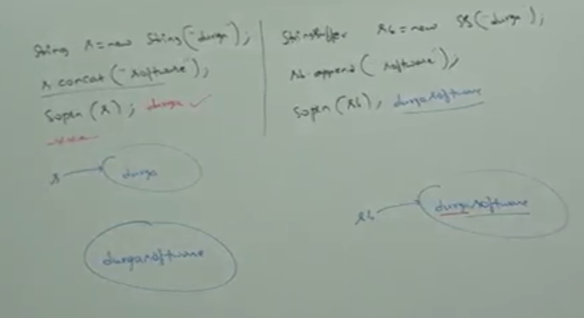

# Difference b/w String and StringBuffered

|  |  |
| --- | --- |
| **String** | **StringBuffered** |
| Immutable String s = “Jatin”; s.concat(“ Bansa”); Sop(s) 🡪 Jatin | Mutable StringBuffered s = “Jatin”; s.append(“ Bansal”); sop(s);🡪 Jatin Bansal |
| equals(): content comparison. equals() is overridden for content comparison | Equals(): reference comparison. equls() is not overridden but inherited from Object class. |

String Pool

1. String s = new String(“durga”);  
   in this case, two objects will be created. One in the heap area and the other in SCP (**String Constant Pool**). s is always pointing to heap object.  
   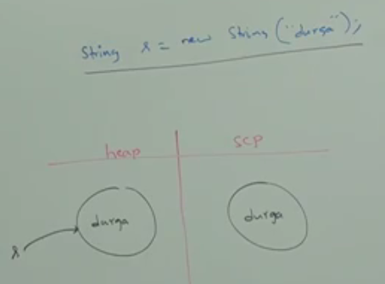

String s = “durga”;  
in this case, only one object will be created in SCP (String Constant Pool). s is always pointing to that object.  
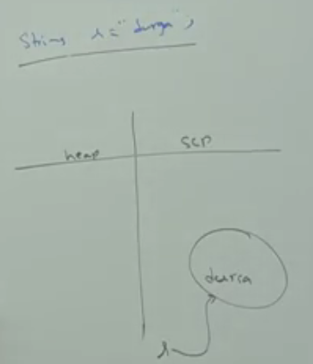  
**NOTE**: object creation in SCP (String Constant Pool) is **optional**. First JVM will check that is there any object already present in SCP with required content. If yes, then the existing object will be reused. If not available, then only a new object will be created. But this rule (whether to create a new object or not) is applicable for SCP but not for heap (with new keyword).

**NOTE**: GC is not allowed to access SCP area (In method area). Hence even though object doesn’t have any reference variable, it’s not eligible for GC if it’s present in SCP area.  
All SCP objects will be destroyed automatically at the time of JVM shutdown or web-server shutdown.

1. How many String objects are created?

3 String objects ☺

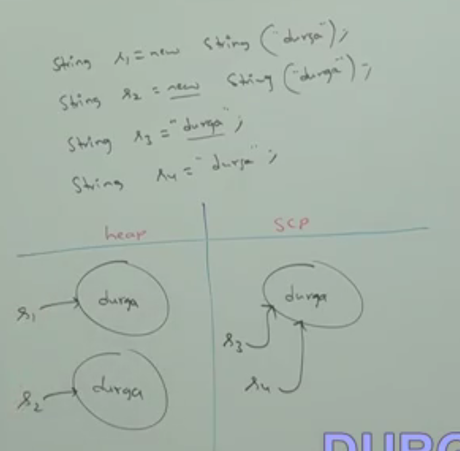  
______________________________________________________________________________________________  
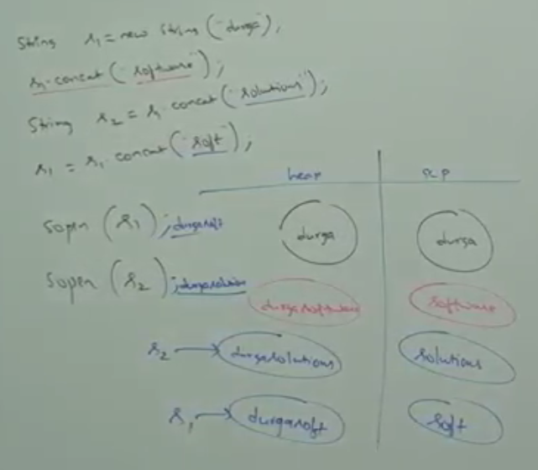

Remember: Only those strings will be placed in SCP (String Constant Pool) which are string literals in your program. None of those strings which are created at runtime due to any method call or any kind of concatenation.  
So in the above example, there are 4 string literals in double quotation marks so there are 4 String constants in SCP. All the other strings created at run time are in heap.

4 on heap

4 on Pool

